Data Handling and Visualization (DSA06)
Name: Prasanna M Reg. No: 1925260244
Set 15: Product Sales Analysis
Question 1. Create a grouped bar chart to visualize the sales of each product for the first quarter. Label the chart elements.
Program (R):
library(ggplot2); library(tidyr)
sales <- data.frame(Product_ID = 1:3,
Product_Name = c("Product A","Product B","Product C"),
January = c(2000,1500,1200),
February = c(2200,1800,1400),
March = c(2400,1600,1100))
long <- pivot_longer(sales, cols = c(January, February, March),
names_to = "Month", values_to = "Sales")
long$Month <- factor(long$Month, levels = c("January","February","March"))
ggplot(long, aes(x = Product_Name, y = Sales, fill = Month)) +
geom_col(position = "dodge") +
geom_text(aes(label = Sales), position = position_dodge(0.9), vjust = -0.3, size = 3) +
labs(title = "First-Quarter Sales by Product", x = "Product", y = "Sales ($)") +
theme_minimal()
Output:
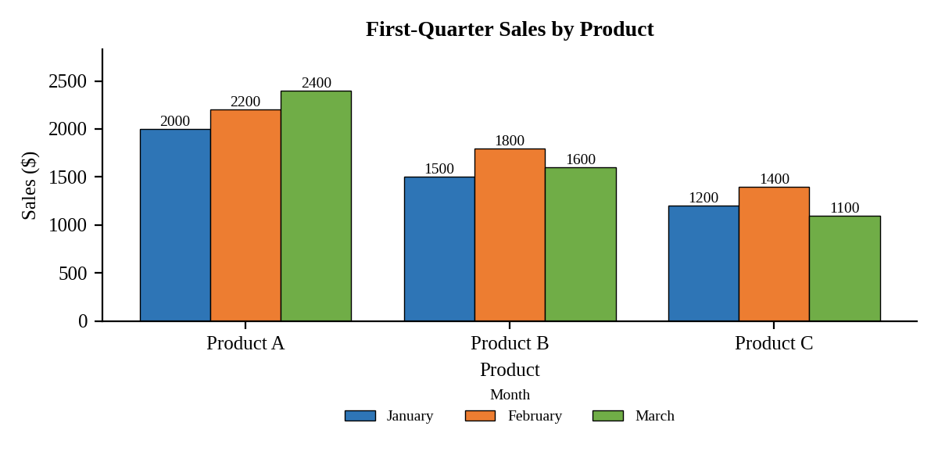
Interpretation:
Product A is the best seller and is the only product that grows every month (2000 to 2400). Product B peaks in February (1800) and dips in March. Product C is the weakest and falls to 1100 in March.

Question 2. Generate a stacked area chart to represent the overall sales trend for all products over the three months.
Program (R):
long$Product_Name <- factor(long$Product_Name)
ggplot(long, aes(x = Month, y = Sales, fill = Product_Name, group = Product_Name)) +
geom_area(position = "stack", colour = "white") +
labs(title = "Overall Sales Trend (Stacked)", x = "Month", y = "Sales ($)", fill = "Product") +
theme_minimal()
Output:
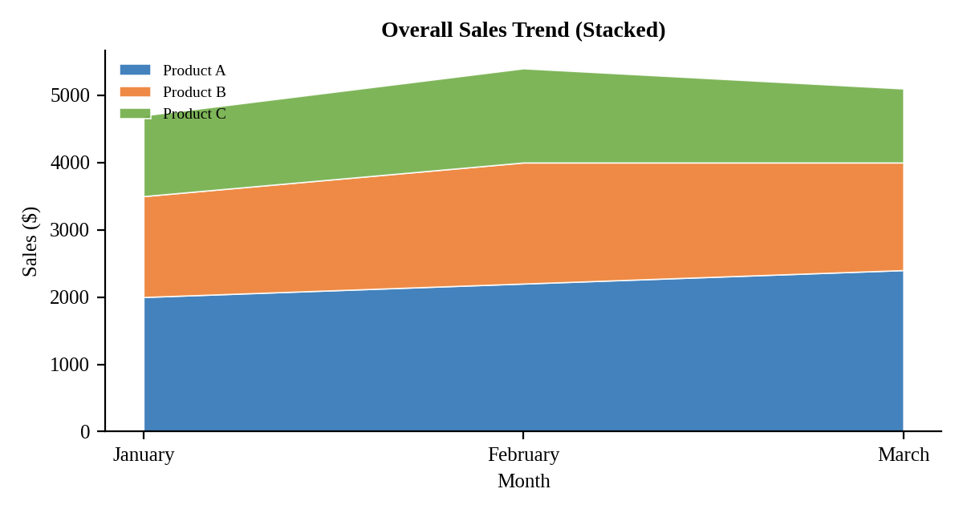
Interpretation:
Total sales rise from 4700 in January to 5400 in February and then ease to 5100 in March. Product A supplies the largest and growing share, while the February peak comes from Products B and C.

Question 3. Build a table to show the monthly sales data for each product. Label the table elements.
Program (R):
sales$Q1_Total <- rowSums(sales[, c("January","February","March")])
library(knitr)
kable(sales, align = "c",
col.names = c("Product ID","Product Name","January Sales","February Sales","March Sales","Q1 Total"),
caption = "Table 15.1: Monthly Sales Data by Product")
Output:
Table 15.1: Monthly Sales Data by Product
Product ID | Product Name | January Sales | February Sales | March Sales | Q1 Total
1 | Product A | 2000 | 2200 | 2400 | 6600
2 | Product B | 1500 | 1800 | 1600 | 4900
3 | Product C | 1200 | 1400 | 1100 | 3700

Interpretation:
Product A has the highest first-quarter total (6600), followed by Product B (4900) and Product C (3700). The combined quarterly sales are 15200.

Question 4. Develop a Tableau dashboard combining the grouped bar chart, stacked area chart, and the table for interactive exploration of sales data.
Procedure (Tableau):
1. Open Tableau, click Connect, choose Text file / Microsoft Excel, select "Monthly_Product_Sales.csv" and open Sheet 1.
2. Select the January, February and March Sales columns, right-click and choose Pivot. Rename the fields to "Month" and "Sales".
3. Sheet 1 (Grouped bar): Columns = Product Name; Rows = SUM(Sales); Color = Month; add labels.
4. Sheet 2 (Stacked area): Columns = Month; Rows = SUM(Sales); Color = Product Name; mark type = Area.
5. Sheet 3 (Table): Rows = Product Name; Columns = Month; Text = SUM(Sales); add Analysis > Totals > Show Row Grand Totals.
6. Click New Dashboard, name it "Sales Dashboard", set Size to Automatic and drag the sheets onto the canvas (charts on top, table below).
7. Select each chart and click the "Use as Filter" icon so that clicking a bar or slice filters the other sheets; keep tooltips enabled.
8. Add a title to every sheet, adjust labels and colours, and save the workbook (File > Save As, .twbx).

Output:
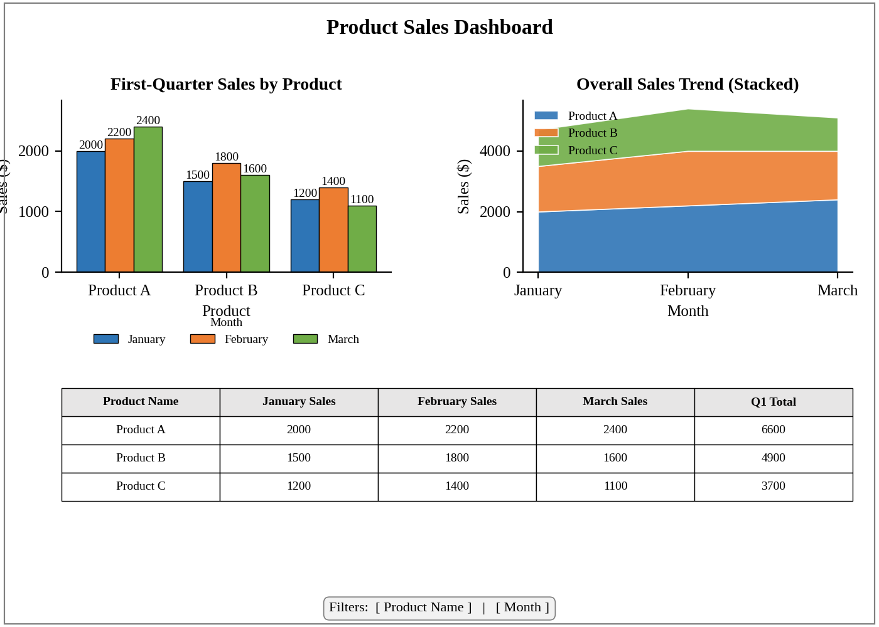
Dashboard layout (preview of the Tableau output).
Interpretation:
Clicking a product or a month filters all three views at once. The dashboard shows that Product A leads in every month, that February is the strongest month overall, and that Product C needs attention.

